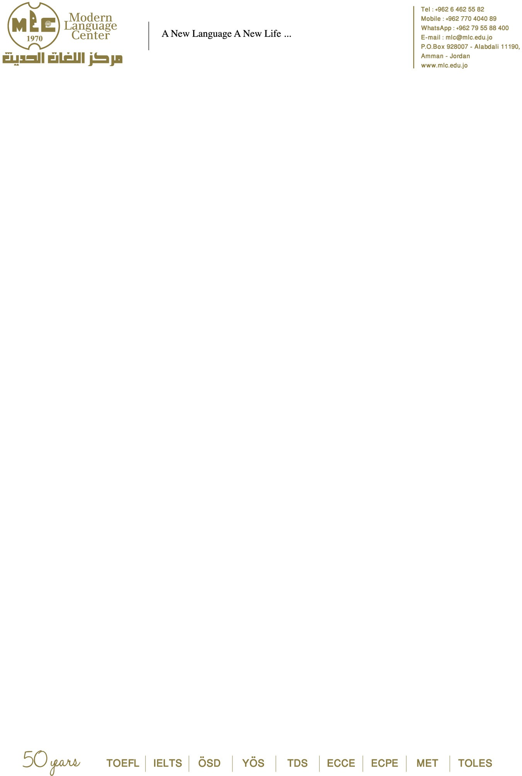

Modern Language Center (MLC)

(AM/ECON 340) Arab & Islamic Culture and Economics in the Middle East

Total Hours: 45
Recommended Credits: 3
Primary Discipline / Suggested Cross-Listings: Economics / Middle East Studies / Arabic Language
Language of Instruction: English
Prerequisites: None.

Course Description
This course offers a comprehensive analysis of the cultural, religious, and socioeconomic foundations that continue to shape modern Middle Eastern economies. Students explore how Arab traditions, Islamic ethical frameworks, and historical legacies influence contemporary labor markets, economic development, consumption patterns, business environments, and long-term strategic planning within the region.

The course investigates why many globally successful economic models fail to deliver equivalent results in the Middle East, despite extensive exposure to Western institutions, foreign aid, modernization initiatives, and international partnerships. Through case studies and primary sources, students assess how factors such as family-based economic structures, religious practices, governance systems, demographic pressures, and political instability contribute to persistent challenges including unemployment, labor informality, reliance on heritage industries, and imbalances between public and private sectors.

Students also examine the philosophical and ethical dimensions of Islamic economics, including wealth distribution, charity, inheritance laws, contractual ethics, and the role of zakat in reducing inequality. Through a mix of theoretical texts, contemporary research, and field observations, students analyze discrepancies between classical Islamic economic principles and practical real-world applications.

The course combines lectures, discussions, field visits, expert guest speakers, and applied economic analysis. Students practice synthesizing quantitative and qualitative data, conducting marketplace observations, interpreting economic discourse, and debating policy recommendations grounded in cultural and religious realities.

Objectives
By the end of this course, students will be able to:

- Describe cultural, historical, and religious factors that influence economic behavior in Arab societies.
- Evaluate the relationship between Islamic principles and modern economic practices.
- Analyze structural barriers that hinder economic development and job creation in the Middle East.
- Describe how cultural expectations shape consumer behavior, business ethics, and labor markets.
- Identify connections between economic actors and political/religious leaders in the region.
- Assess external influences—including globalization, foreign aid, and Western economic prescriptions—on local economies.

- Produce analytical writing and oral presentations integrating theory, field data, and economic case studies.
- Develop comparative insights into Islamic, capitalist, and socialist economic systems.
.
Course Requirements
Attendance and active engagement in course discussions are essential. Students must complete assigned readings before class and participate in field-based activities including visits to markets, economic institutions, and relevant guest lectures.

Assignments include:

- Weekly Presentations: Students research an assigned topic, present it to the class, and lead a discussion.
- Homework: Weekly short papers, marketplace observations, and analytical exercises.
- Opinion Polls: Students conduct surveys in Amman to compare perceptions of economic issues and marketplace dynamics.
- Small Projects: Comparative studies of viewpoints from locals, peers, or language partners.
- Final Project: A 10–15 page research paper supported by course materials, followed by a formal presentation before instructors and peers.

- Late submissions are not accepted. Academic integrity and professionalism are required at all times.

Grading

Participation: 40%
Homework: 20%
Small Projects and Presentations: 10%
Final Project and Presentation: 30%

Readings
Required and suggested readings include works addressing Islamic economic thought, Middle Eastern economic history, cultural influences on markets, and contemporary development challenges:

- Timur Kuran — The Long Divergence: How Islamic Law Held Back the Middle East
- Donna Marsh — The Middle East Unveiled
- Vali Nasr — The Rise of Islamic Capitalism
- Roger Owen — The Middle East in the World Economy 1800–1914
- Maxime Rodinson — Islam and Capitalism
- Relli Shechter — Smoking, Culture, and Economy in the Middle East
- Charles Tripp — Islam and the Moral Economy

Curated excerpts are assigned; no external URLs included.

Additional Resources
Supplementary materials may include:

- Reports from regional economic research centers
- Contemporary articles on Islamic banking and economic reform
- Analyses of cultural influences on business ethics
- Policy studies on unemployment, state reform, and development challenges

These materials enrich understanding of how cultural, political, and religious factors shape economic outcomes.

Outline of Course Content
Each topic is covered in 3–4 weeks:

Topic 1 – Culture and Economics
- Relationship between culture and economic systems
- Human investment across cultural categories (men, women, children)
- Technology, production, ownership, consumer behavior, exchange regimes

Topic 2 – Ethics and Religion
- Ethics of Islamic economics compared to global systems
- Ramadan economics: ownership, inheritance, charity, Eid customs
- Gap between Islamic economic principles and practices

Topic 3 – Business and Banking
- Gifting, exchange norms, and consumer orientation in modern markets
- Islamic banking vs. conventional banking systems
- Historical influences of feudalism, slavery, and class hierarchy
- Case studies: tourism and telecommunications marketing

Topic 4 – Comparative Systems

- Islamic vs. socialist vs. capitalist systems
- Transitions from family-based structures to modern corporations

Cultural strengths shaping land ownership, governance, water management, and foreign interaction

Modern Language Center (MLC) Email: mlc@mlc.edu.jo
Tel/WhatsApp: +962777890587
Jabal Al-Luweibdeh, Amman – Jordan
Where Every Language Finds Its Voice كـــل لســــــــــان بانســـــــــان

